FINGERPRINT COMPRESSION BASED ON SPARSE REPRESENTATION
In this project we are compressing fingerprint images using SVD algorithm as this images size will be huge and require more bandwidth and time to transfer through internet so we need an efficient way to compress such image to transfer faster. SVD algorithm will scan each pixel of the image and then replace high intensity pixels with low intensity pixels to reduce storage size. SVD algorithm will maintain dictionary of pixels and while compressing it will scan that dictionary to replace low intensity pixels with high intensity. The resultant image after compression will have same quality of image with less storage size.
To compress and test images we are using following sample images
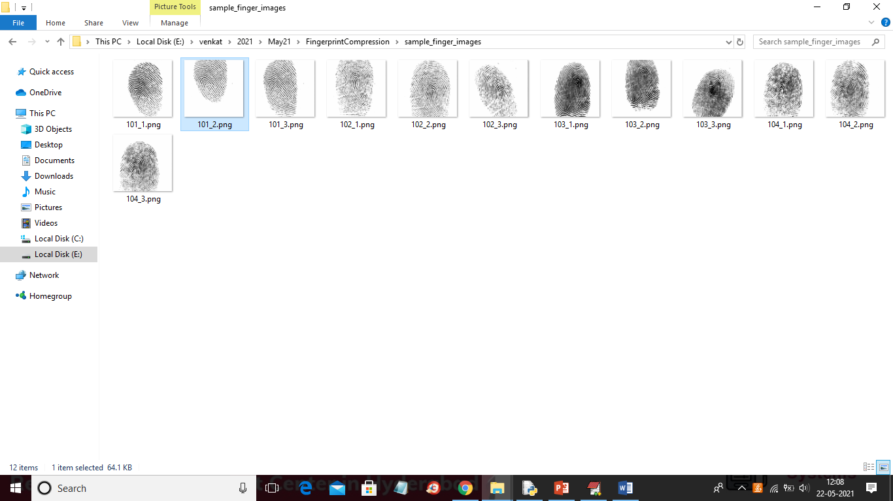
SCREEN SHOTS
To run project double click on ‘run.bat’ file to get below screen
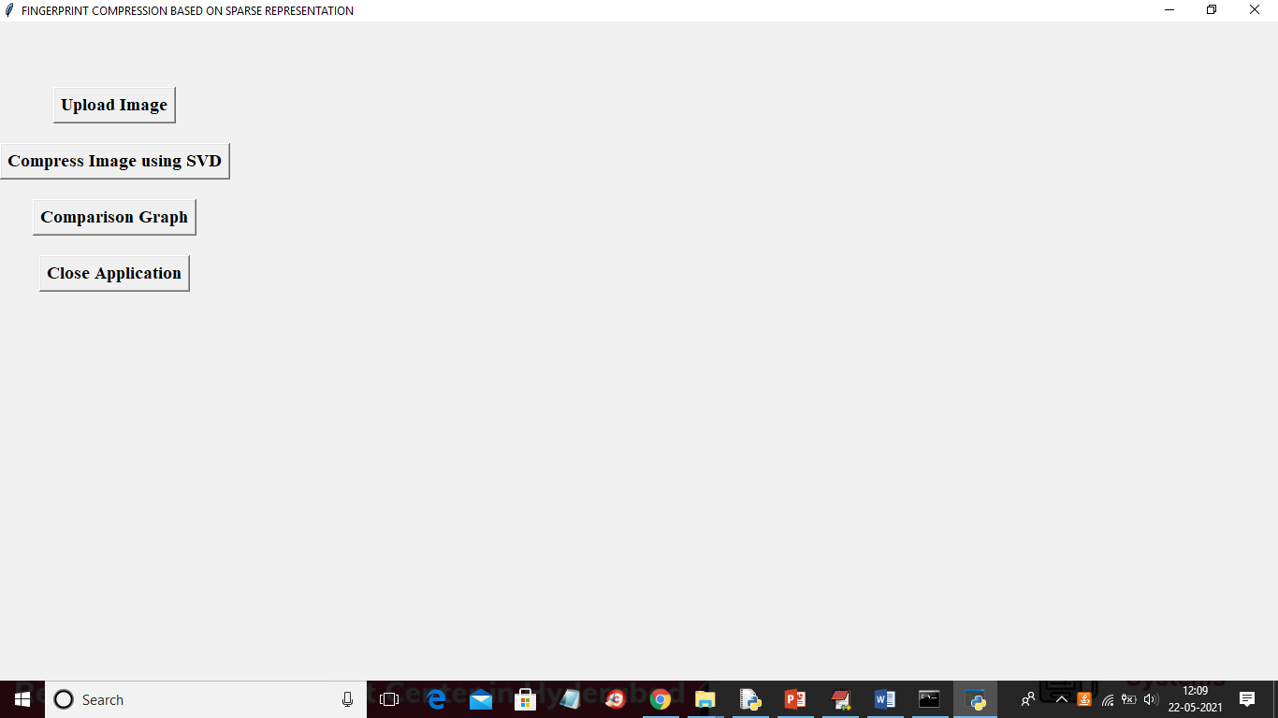
In above screen click on ‘Upload Image’ button to upload image
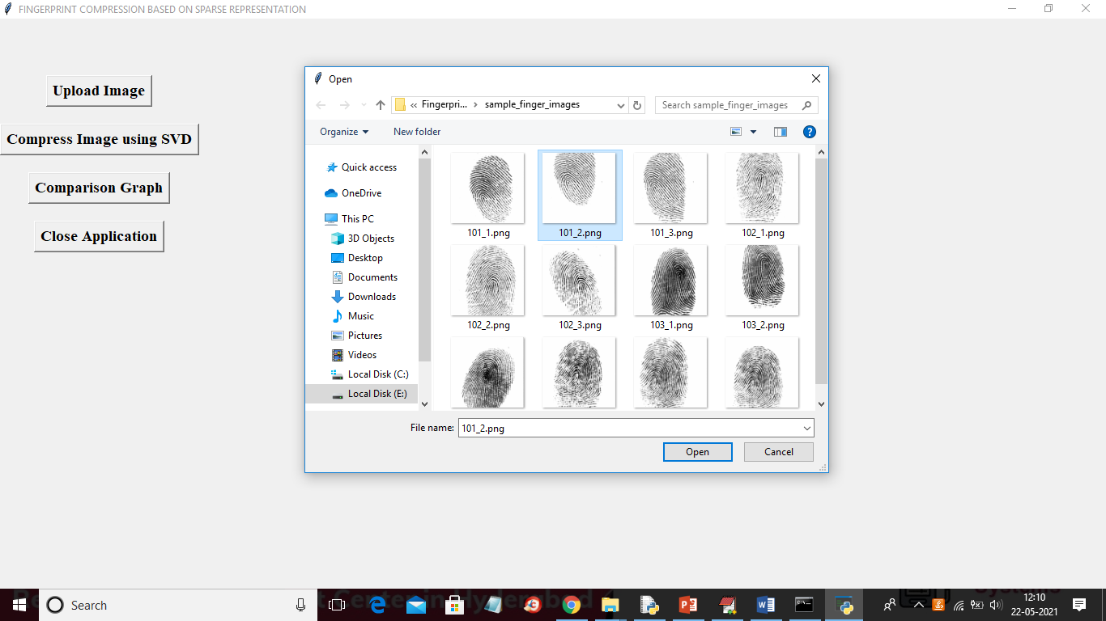
In above screen selecting and uploading ‘101_2.png’ file and then click on ‘Open’ button to load image and to get below screen
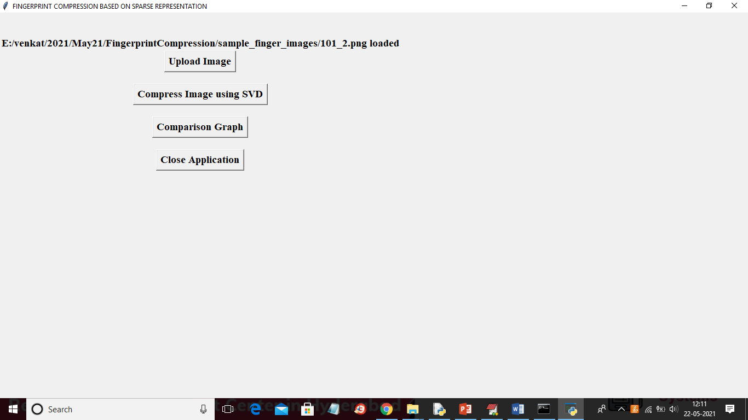
In above screen image loaded and now click on ‘Compress Image using SVD’ button to compress image and then will get below screen
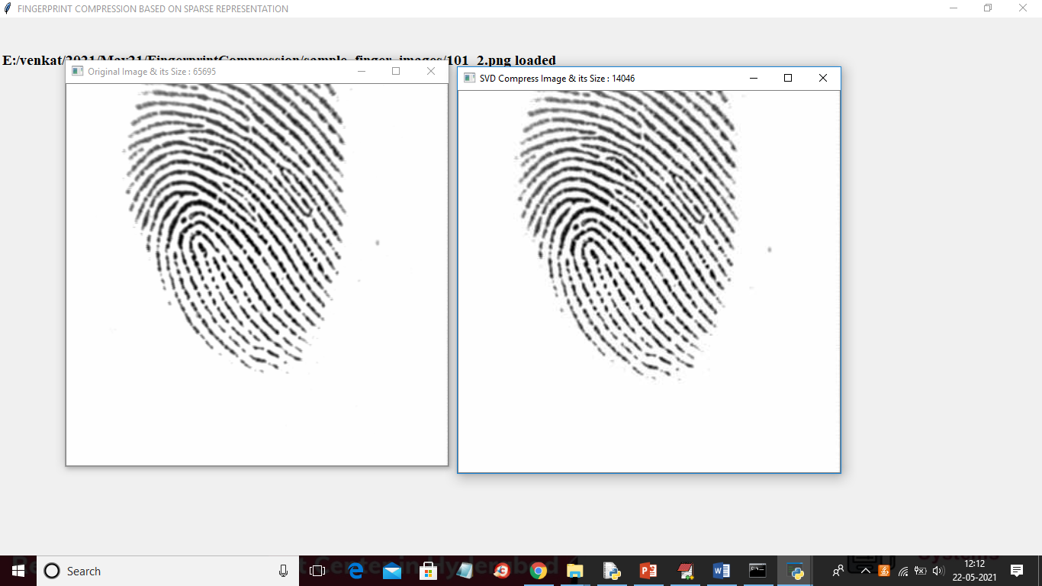
In above screen first image is the original image and in the title bar of image you can see their size in bytes where original image having size as 65695 bytes and SVD compress image size is 14046 bytes and the same size you can see in below image directory
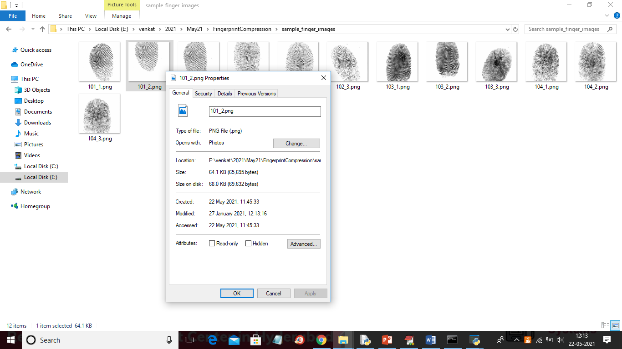
In above screen for 101_2.png the image size is 64.1 KB and see the same image size in compress folder after compression
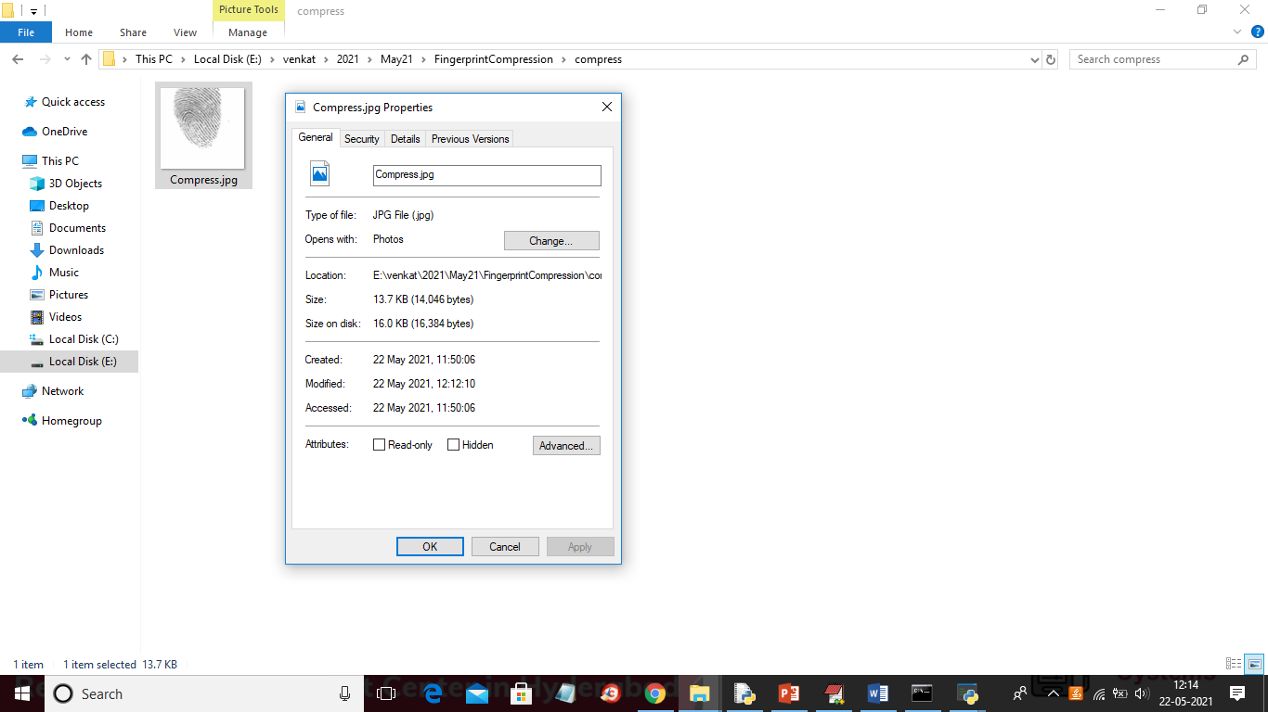
In above screen after compression the same image size is reduced to 13.7 KB. Similarly you can upload other images and test and now click on ‘Comparison Graph’ button to get below graph
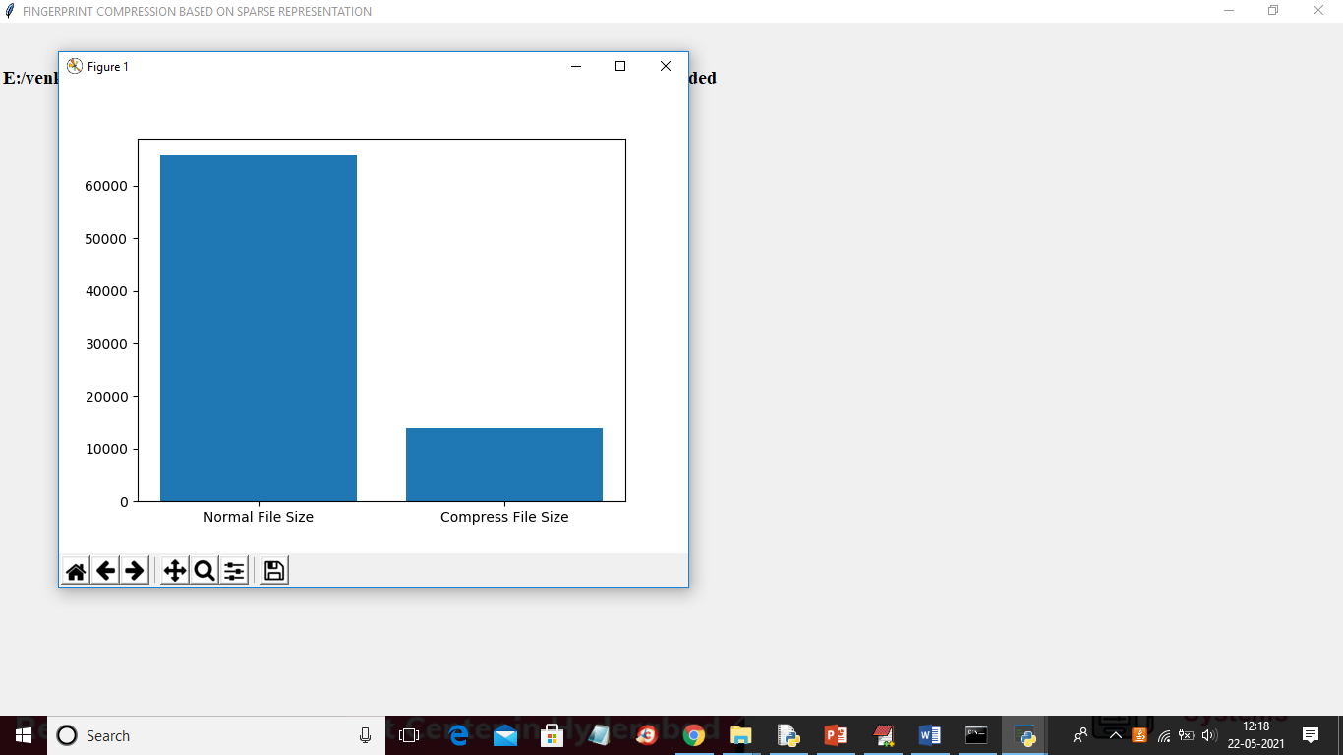
In above graph x-axis represents technique name and y-axis represents image size and in above screen we can see after compression images size is reduced

